Results of 2021 coldwater temperature monitoring and recommendations for future coldwater habitat enhancement measures
Cheticamp River Salmon Association - October 2021

Introduction
The Cheticamp River Salmon Association (CRSA) has been working with Cape Breton Highlands National Park and other project partners since 2017 to gain a better understanding of summer water temperatures on the Cheticamp River. The findings of the first four years of the investigation included confirmation that critical thresholds (25°C) are regularly exceeded and fish are exposed to prolonged periods of temperatures above 20°C at sites monitored throughout the lower Cheticamp. Looking to build on their investigation, the CRSA partnered in 2020 with a research team from Dalhousie University’s Groundwater Lab to undertake additional thermal mapping work on the Cheticamp. Using a drone equipped with a thermal imaging camera, the research team identified various coldwater input (e.g., diffuse seepage and springs) locations.

Continuing with the thermal mapping work, in 2021 the CRSA undertook follow-up monitoring of three of these locations to quantify the temperature differences at the coldwater input sites over the course of the summer (June 15 – September 15 monitoring period). With help from consultant Charles MacInnis, the CRSA also assessed the suitability of the sites as locations for future coldwater habitat enhancement activities. The following report provides an overview of these findings.

Coldwater input locations
The research team led by Dalhousie University graduate student Kathryn Smith identified locations of coolwater inputs on the lower Cheticamp River, from the estuary to Long Pool (see map below showing the identified locations; map created by Kathryn Smith).
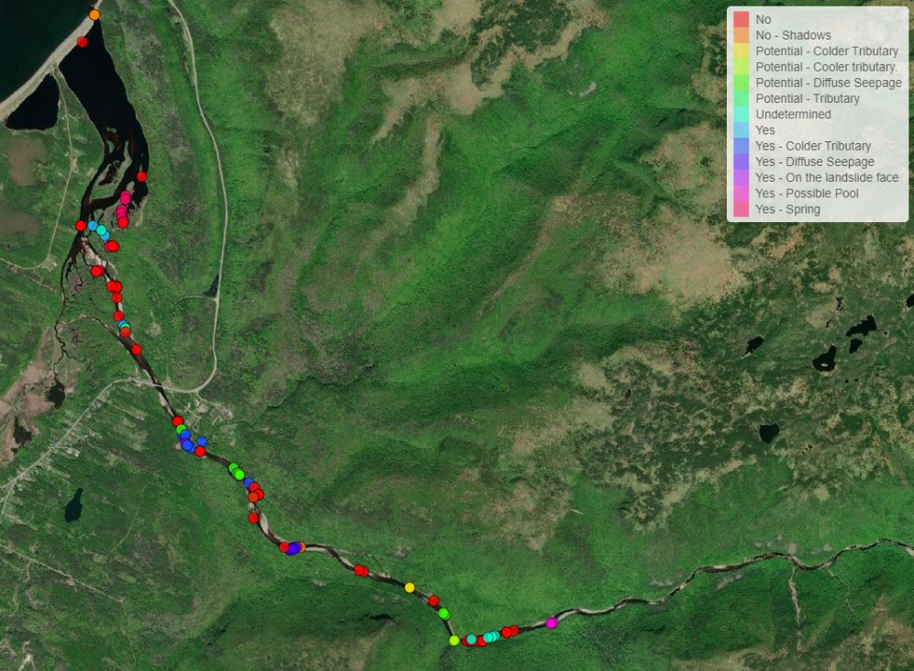
The CRSA monitored water temperatures at three of the coldwater input locations identified by the team from Dalhousie, two sites of diffuse seepage and one location of a spring (see map). The CRSA focused on these locations as sampling with handheld thermometers confirmed significantly cooler water temperatures and the CRSA considered these locations as potential candidates for locations of future coldwater habitat enhancement activities.
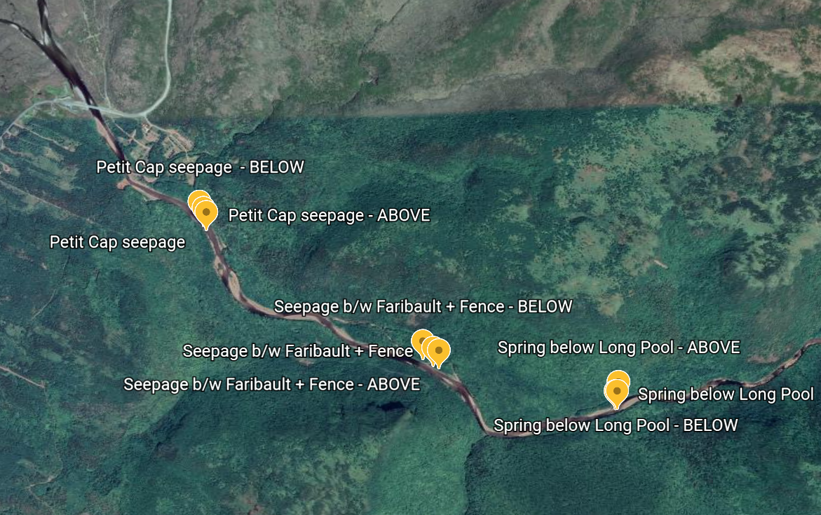

Methods and findings
The CRSA used three HOBO water temperature loggers to monitor each of the three coldwater input locations; one logger was installed at the location of the identified coldwater input, and the other two were installed above and below the coldwater source. The loggers were programmed to record water temperature at one-hour intervals and data was collected over the CRSA’s 3-month summer study period – June 15 – September 15.

The data confirmed that the three locations were all sites of significant coldwater inputs. The temperatures were similar at the spring below Long Pool and the location of diffuse seepage above Petit Cap, with the diffuse seepage site between Faribault and Fence Pool having slightly warmer temperatures (see map below for comparison of the three sites).
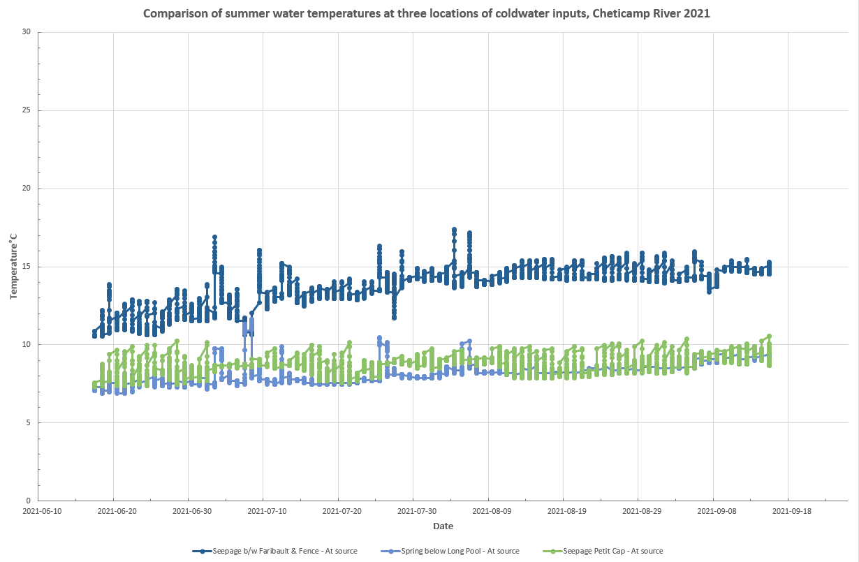

Water temperatures at the spring below Long Pool were an average of ~8°C colder than at the loggers above and below the spring (average difference of 8.0°C above and 7.8°C below). The maximum temperature differences were just over 15°C (max of 15.3°C between the spring and site above and 15.2°C below).
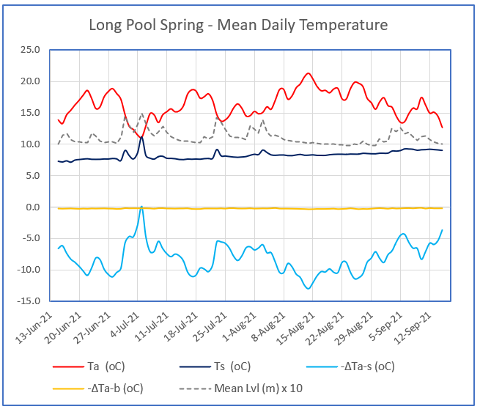
Figure 2. Mean daily water temperatures at spring below Long Pool: Ta – above spring, Ts – at spring;
Temperature differences between readings ΔTa-s above and at spring, and ΔTa-b above and below spring. Daily mean water level at Petit Cap hydrometric gauge (FC-001).

Water temperatures at the diffuse seepage location above Petit Cap were an average of ~7.5°C colder than at the loggers above and below the site (average difference of 7.9°C above and 7.3°C below). The maximum temperature differences were higher than at the monitoring site below Long Pool, with a maximum of 20.2°C recorded between the Petit Cap seepage location and control site above, and a maximum difference of 16.6°C between the source and the site below).
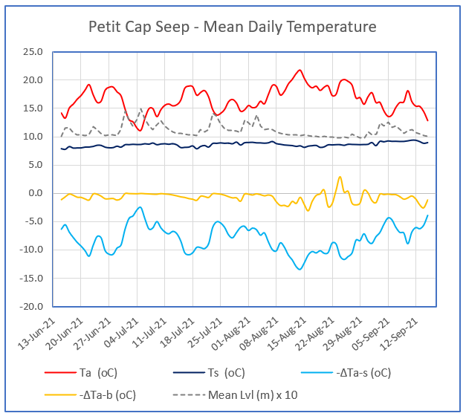
Figure 3. Mean daily water temperatures at seep at Petit Cap: Ta – above seep, Ts – at seep: Tempera-
ture differences between readings ΔTa-s above and at seep, and ΔTa-b above and below seep. Daily mean water level at Petit Cap hydrometric gauge (FC-001).

Water temperatures at the diffuse seepage location between Faribault and Fence Pool were an average of ~10°C colder than at the loggers above and below the coldwater source (average difference of 10.0°C above and 10.1°C below). The maximum temperature difference between the seepage site and both the locations monitored above and below it was 2.8°C. Periodically the temperatures recorded at the coldwater location above Petit Cap were either the same, or slightly warmer, than at the comparison sites above and below.
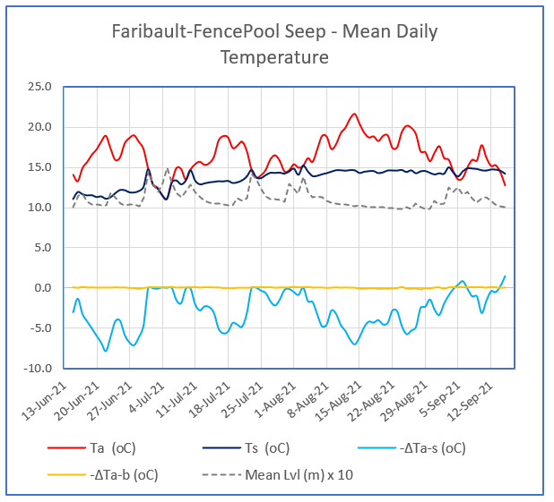
Figure 4. Mean daily water temperatures at seep between Faribault Brook and Fence Pool: Ta – above
seep, Ts – at seep: Temperature differences between readings ΔTa-s above and at seep, and ΔTa-b above and below seep. Daily mean water level at Petit Cap hydrometric gauge (FC-001).

Recommendations for future coldwater habitat enhancement activities
Interested in exploring ways to help mitigate climate change impacts on the Cheticamp, the CRSA hired project consultant Charles MacInnis to help prioritize locations and make recommendations for potential coldwater enhancement activities. In July 2021, Charles visited the Cheticamp and identified the following sites as candidates for future work, based on their potential for significant positive impacts as well as the accessibility of the locations:

Springs above Faribault
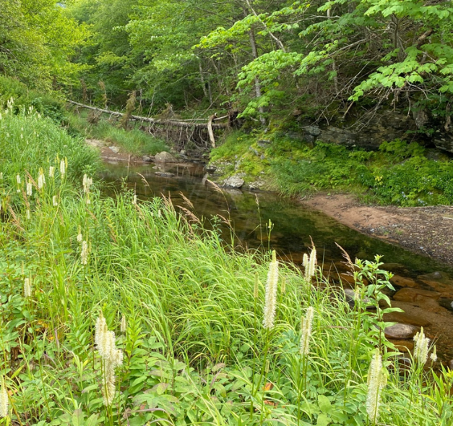
Charles determined that accessing the spring below Long Pool would be difficult with heavy equipment due to its distance from previously established access routes combined with the predominance of large rock and boulders in this reach of river.

Charles recommended instead focusing future efforts on a back channel further downstream (but also above Faribault Brook). By installing a rock sill above where the back channel connects with the river, Charles explained the goal would be to back flood the channel. This would increase the benefits of the springs in the area as the spring-fed water in the back channel would be more likely to feed into the main river.
Diffuse seepage location between Faribault and Fence Pool
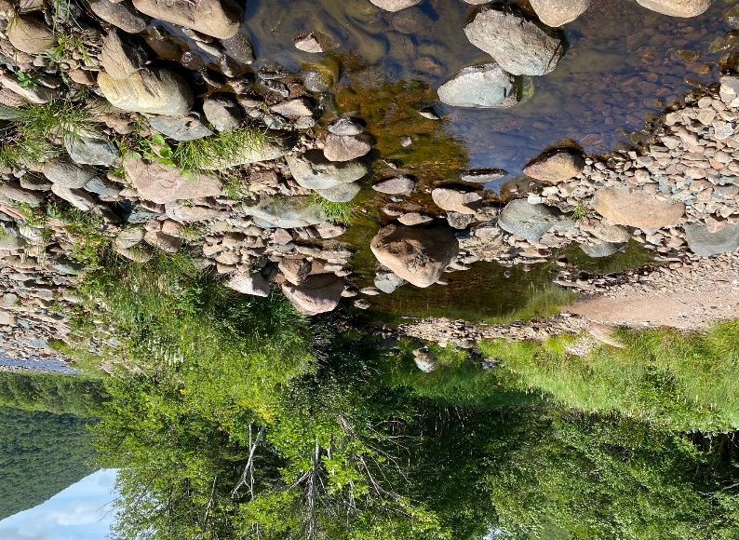
This location has potential as a site for enriching coldwater refugia habitat for juvenile salmon and trout.

Charles recommended relocating some of the large substrate to create a larger and more accessible entrance as well as digging a narrow and deep trench to a back channel containing cooler water. In addition, Charles recommended installing a rock sill above the entrance of the back channel to hold the elevation and maintain sufficient depths. These activities could be paired with riparian planting to increase shading and/or addition of increased instream cover.

Charles also suggested the possibility of increasing the depth of the main channel, above the back channel, to increase the benefits of coldwater seepage occurring along the bar on the right bank.

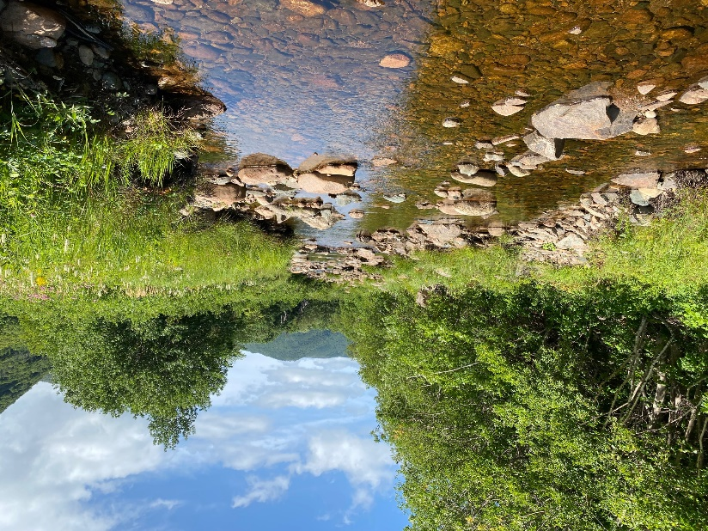
Back channel above Fence Pool
Although this was not one of the coldwater locations monitored by the CRSA in 2021, Charles recommended installing one or two rock sills in the back channel to raise the water levels and increase available habitat for juveniles.

Again, these activities could be paired with riparian planting to increase shading and/or addition of increased instream cover. Charles also noted that these structures would not require the use of heavy equipment, but could be installed by hand by the CRSA’s work crew.

